http://www.azcentral.com/travel/arizona/features/articles/0822azfailures0823.html

The empty bus stop
A set of lonely signs along Interstate 10 near Third Street and Third Avenue used to point to an Express Bus Terminal - one that was never used, never finished. The terminal, which cost $9.4 million to add to the I-10 tunnel, was supposed to serve express buses to the city's outlying areas. Commuters would take elevators from the Margaret T. Hance Park down to the terminal. Then buses would leave the terminal and speed along the carpool lanes along I-10. At the time, though,, there was not enough demand for express bus service. A few years ago, the city looked at the possibility of finishing the terminal, now that bus service might be coupled with the light-rail line. If they do decide to use it, however, they will have to make new signs. The old ones fell down years ago.

http://phoenix.gov/FIRE/20515a.html

BUS TRANSIT TUNNEL
There is a single Bus Transit Tunnel between the two vehicular tunnels to service bus traffic. This tunnel will not be in service for some time and has large fence gates at each end of the tunnel to restrict access. Gates will be large enough to allow fire apparatus to enter. Gates will be chained and padlocked. Companies can easily cut chains to make emergency access to the tunnel.
It is extremely difficult to turn fire apparatus around in this tunnel.
Four access doors provide access from this transit tunnel to the vehicular tunnels (two on the eastbound side and two on the westbound side) and are located approximately one-third of the way in from the vehicular entrance/exit points. These doors are locked from the transit side in order to avoid having unauthorized personnel open a door and step into traffic. A lockbox with keys in it is mounted next to the door.

http://travisschnepp.wordpress.com/2007/12/28/discovering-phoenix-deck-park-tunnel/

Officially, it’s known as the Margret T. Hance Park and the Papago(more appropriately referred to as Tohono O’odham) Freeway Tunnel. The tunnel was completed in 1990 as part of the I-10 interstate which stretches from Santa Monica, CA to Jacksonville, FL. Located in Central Phoenix, the half mile long tunnel lies between 3rd Ave and 3rd St. It consists, actually, of three tunnels: One westbound, One east bound, and One for a city bus terminal. I suppose the city/state/fed ran out of money to finish the third tunnel because it isn’t used. The idea was to have commuter buses enter the center tunnel via the east and west bound carpool lanes. Elevators (and maybe stairs) in the tunnel would carry commuters from the bus terminal to the park above and awaiting city buses. Perhaps the new Metro Light Rail, which will pass over the tunnel, will lead to renewed interest in the bus tunnel.
Atop the tunnel (which I admit is more like a trench with a grassy roof) sits Margret T. Hance Park. Margret T. Hance was the first female Mayor of Phoenix, serving from 1976 to 1983. The park, completed and named in 1991 serves as a major hub for Central Phoenix Real Estate. The park is open 6am-10pm and offers fountains, picnic areas, walking paths, and more. Adjacent to the park is the Burton Barr Central Library, the Irish Cultural Center, Arizona Puppet Theatre, and the Japanese Friendship Garden. The ‘Deck Park’ will host the 44th Annual Scottish Highland Games in late February 2008. Maybe I’ll see you there and we can toss a caber or two.

http://www.valleymetro.org/Valley_Metro/Publications/Destinations/dest04winter.pdf

Completion of
Deck Park Station
to Be Studied
The Valley Metro Board
Directors has authorized
procurement of several consultant
contracts for FY04. One of
contracts includes a feasibility study
completing the express bus station
I-10 Deck Park Tunnel system.
While driving through the tunnel,
you’ve probably noticed the entrances
to the station off the east- and westbound
HOV lanes. The “shell” of the station
was built when the I-10 tunnel was completed
more than 10 years ago, but
station remains incomplete.
Since the proposed, new Regional
Transportation Plan calls for improvements
to RAPID and express bus
completing the station is now being considered.
The feasibility study, which
direct the future of that effort, is expected
to be finished by June 2004.
http://www.npr.org/templates/story/story.php?storyId=5522133&ft=1&f=1007

 | 
  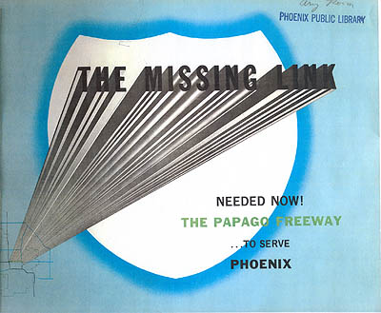
  Cover of 1957 Papago Freeway study. (Phoenix Public Library)
Interstate 10 (the Papago Freeway) was extremely controversial through Phoenix. The freeway was first planned through the city in 1957, then revised in the 1960 freeway plan. A 1970 freeway plan showed Interstate 10 arching up to 100 feet above Central Avenue, with spiraling "Helicoil" ramps to connect the freeway to 5th-7th Avenues, and 5th-7th Streets.
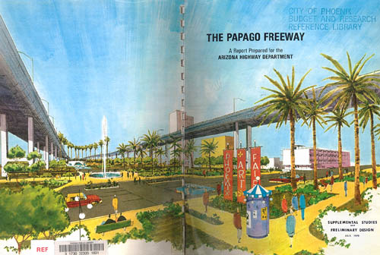
Cover of 1970 Papago Freeway study. (Phoenix Public Library)
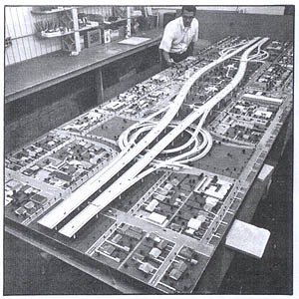  Model of the freeway over Central Ave. | 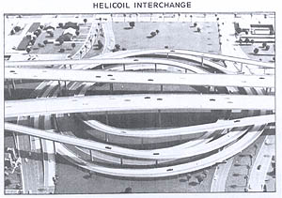  Model of the Helicoil Interchange.

Nina Pulliam, wife of Eugene Pulliam (publisher of the Arizona Republic) saw these plans one night and remarked how she didn't like them. This was enough to change the editorial position of the influential paper. Combined with anti-freeway sentiments in the early 1970s, this led to the Papago Freeway's design rejection in a public vote. A revised design would not be created until 1983, which had the freeway depressed below grade and a ten block park, the Margaret T. Hance Deck Park, preserving continuity between 3rd Street and 3rd Avenue.

Construction History
- 1964: Miles 0-10 (I-10 bridge over the Colorado River to west of Quartzsite)
- 1962: Miles 10-17 (west of Quartzsite)
- 1966: Miles 17-19 (Quartzsite bypass)
- 1964: Miles 19-31 (Quartzsite to Brenda)
- 1972: Miles 31-94 (Brenda to Tonopah)
- 1978: Miles 94-128 (Tonopah to Litchfield Road)
- 1984: Miles 128-140 (Litchfield Road to 51st Ave)
- 1985: Miles 140-142 (51st Ave to 31st Ave)
- 1989: Miles 142-143 (31st Ave to I-17 and portions of the Stack interchange)
- 1990: Miles 143-146 (I-17 and the Stack interchange to 3rd Street)
- 1988: Miles 146-150 (3rd Street to I-17)
- 1965: Miles 150-153 (I-17 to 40th Street), reconstructed 1988
- 1968: Miles 153-156 (40th Street to Baseline Street), reconstructed 1988, 1997, 2000
- 1967: Miles 156-161 (Baseline Street to Chandler Blvd), reconstructed 1988, 1997, 2000
- 1968: Miles 161-198 (Chandler Blvd to Highway 84)
- 1967: Miles 199-212 (Highway 84 to Picacho)
- 1962: Miles 212-232 (Picacho to Marana Air Park exit)
- 1964: Miles 232-240 (Marana Air Park to Tangerine Road)
- 1966: Miles 240-255 (Tangerine Road to Miracle Mile)
- 1962: Miles 255-260 (Miracle Mile to 29th Street), reconstructed 1996
- 1964: Miles 260-261 (29th Street to 6th Ave), reconstructed 1996, 2004
- 1967: Miles 261-267 (6th Ave to Valencia Road), partial reconstruction 1991
- 1964: Miles 267-275 (Valencia Road to Houghton Road)
- 1959: Miles 275-279 (Houghton Road to Vail Road, bypass of original highway)
- 1962: Miles 279-289 (Vail Road to west of Marsh Station Road)
- 1955: Miles 289-290 (Original US 80 expressway, unmodified)
- 1959: Miles 290-299 (Marsh Station Road to Skyline Road)
- 1962: Miles 299-303 (Skyline Road to AZ 90)
- 1974: Miles 303-311 (Benson Bypass)
- 1964: Miles 311-322 (Benson to Texas Canyon Rest Area)
- 1959: Miles 322-336 (Texas Canyon to Willcox West)
- 1969: Miles 336-343 (Willcox)
- 1962: Miles 343-352 (Willcox to US 191)
- 1959: Miles 352-354 (US 191 to US 191Y)
- 1964: Miles 354-362 (US 191Y to Bowie West)
- 1968: Miles 362-368 (Bowie bypass)
- 1964: Miles 368-378 (Bowie to San Simon)
- 1968: Miles 378-386 (San Simon)
- 1962: Miles 386-393 (San Simon to NM State Line)
The section from Buckeye Road to I-17 was originally constructed in 1965 as I-510 (later I-410) and reconstructed in 1988. Miles 147-150 were signed as SH 51 between 1988 and 1990, until I-10 was completed. Miles 255-262 were originally built in 1953 as AZ 84A, an expressway bypass of Tucson, and upgraded to I-10 between 1959 and 1962.
There is a construction project in Tucson to widen Interstate 10 through downtown. This section of freeway, one of the oldest in Arizona, was reconstructed in 1996 but not significantly widened at the time. The current project will bring Interstate 10 to 8 lanes (4 each direction) through downtown Tucson, and is estimated to be completed by 2010.
There are plans to reconstruct Interstate 10 from the Mini-Stack (Loop 202/Arizona 51) to Ray Road through Phoenix into a dual freeway configuration. More information can be found on the Phoenix focus page.

Business Loops
I-10 has had several business loops. The following are current ones:
- Quartzsite – 2.4 miles, along old US 60.
- Benson – 3.2 miles. Old AZ 86.
- Willcox – 8.0 miles. Old AZ 86.
- Bowie – 4.0 miles. Old AZ 86.
- San Simon – 3.5 miles. Old AZ 86.

Former Business Loops
- Phoenix – Grand Avenue from I-17 to Van Buren Street, Van Buren Street from Grand Ave to 44th Street, and 44th Street (Hohokam Expressway) from Van Buren to I-10. Former US 60 to 44th Street.
- Tucson (1) – AZ 77 from Miracle Mile interchange to Oracle Road, then south on Oracle Road to Drachman Rd, then south on 6th Avenue to I-10. Also former US 80/89 from Oracle Road to I-10.
- Tucson (2) – Tucson-Benson Highway from Park Ave (exit 262) to Exit 267. Old US 80.
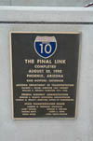 | Plaque unveiled at the completion of I-10, in August 1990. This plaque is located atop Hance park, near the Phoenix Public Library. Photo taken 9/05 by Terry Nash.

http://www.rockymountainroads.com/i-010_az.html

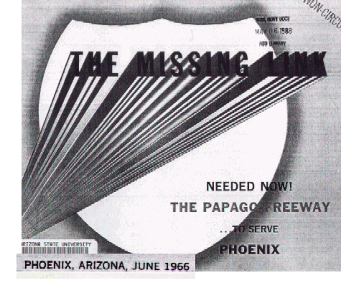
"Now" ended up being 24 years. This 1966 pamphlet was published by the City of Phoenix to promote the Papago Freeway through town. The Papago's last link was opened August 10, 1990.
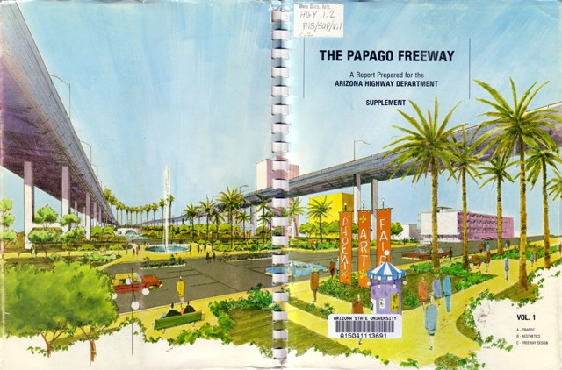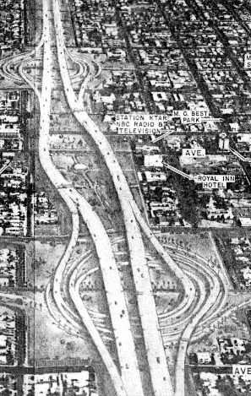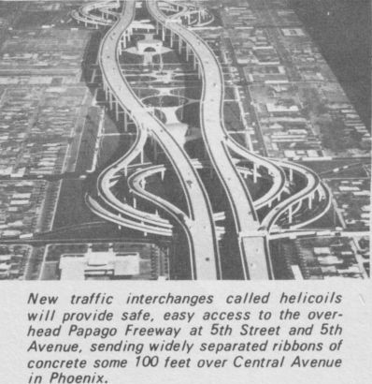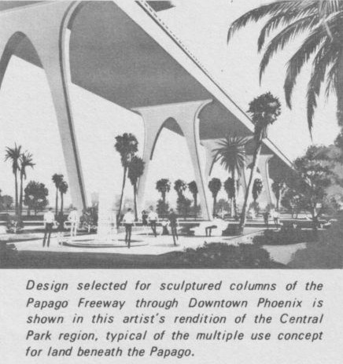
Welcome to the World of Tomorrow! The Papago's original design had the lanes arching 100 feet over Central Avenue, with "helicoil" ramps connecting to 3rd and 5th Avenues (foreground) and 3rd Street (background). Traffic would make a 270° loop to reach ground level.
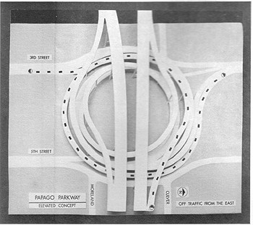
Note that traffic would turn to the left, rather than the right as in cloverleaf ramps. (Illustrations: ADOT)
Until 1972, this seemed to be a done deal. But then, the Arizona Republic newspaper launched a campaign against it. That, coupled with growing anti-freeway sentiment nationwide, defeated it in a 1973 ballot. A proposition in 1979 proposed the "Grid Plan", which would have made improvement to existing surface streets, but would not have built any freeways. This too was defeated, which was seen as a move back toward freeways. I recall one ad for the Grid Plan, with the announcer saying "They want to build a freeway out here?" That "out here" is now heavily developed.
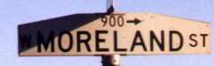
For all the time in between, the "Moreland Corridor" was a partly cleared stripe through town.
The project finally got rolling again in 1983 with a plan for a below-grade route through the center of town, and a tunnel covered by a park at Central Avenue. This was the plan that finally got built. I hope to have more details on the campaign against it.
http://www.arizonaroads.com/urban/papago.html

