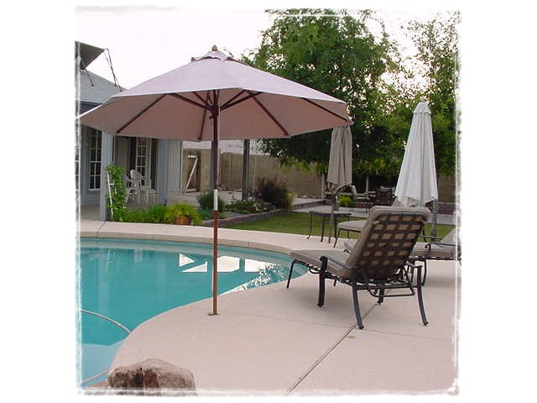
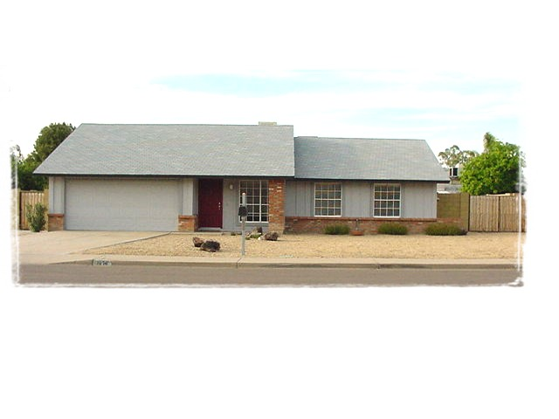

For Sale By Owner

3816 West Michigan Avenue
Backyard Paradise! Sparkling pool w/ waterfall new in ’01!
ONLY $190,000
Beautifully updated 1980 home featuring a lush backyard with pool, new hardwood floors, remodeled kitchen and baths. Kitchen is light and bright, opening onto a dining and family room with a bay window and French doors (a great layout for entertaining). Completely updated Master Bath with steam shower, cherry vanity and granite countertop. New light fixtures and ceiling fans compliment the neutral colors of the freshly painted interior. There is nothing left for you to do, but move in!
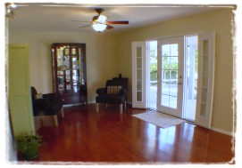
Open House Saturday and Sunday 10:00 – 4:00. 602-769-0983.

- 3 Bedroom, 2 bath
- 1,450 sqft living space; 9500+ sqft lot
- Extra deep 2 car garage
- Great room plus formal living room
- Sparkling Saltwater Pool w/ Waterfall
- Beautiful landscaped and lighted backyard wired for patio speakers
- Hardwood floors
- Fresh interior & exterior paint
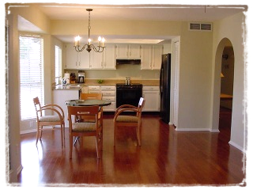
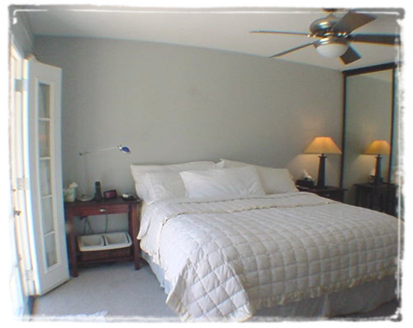
- Remodeled kitchen with gorgeous granite countertops and huge pantry
Master Suite completely redone in 2003!
Living Room: 12x21; Dining/Family: 12x23½; Kitchen: 12x10; Master: 11½x14; 2nd Bedroom: 10½x11½; 3rd Bedroom: 10x11

- Inside laundry
- Refrigerator negotiable (washer & dryer do not convey)
- Master suite w/ Walk-in closet & French door to pool
- Beautifully landscaped lot with large covered patio
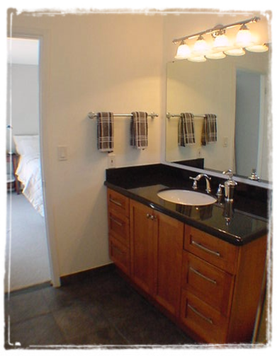
- Large RV gate and parking
- Newer appliances, roof, a/c
- Neat and clean – move in ready!

